**Practical No. 1**

**Aim: -** HDFSList of Commands

Hdfs dfs -ls

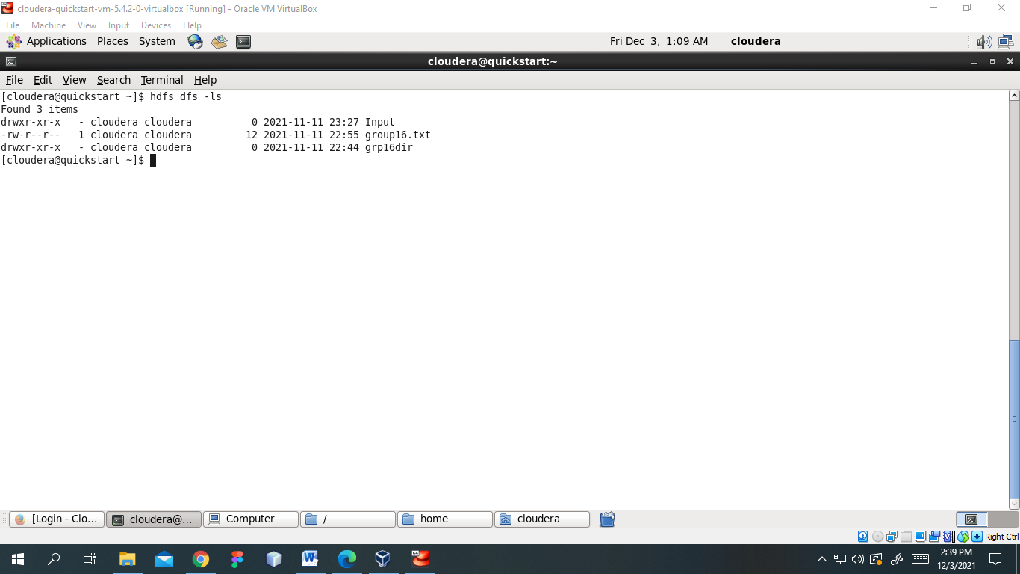

-touchz

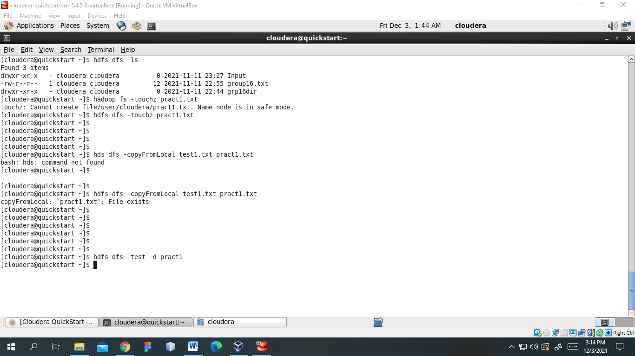

-copyFromLocal



-test -d

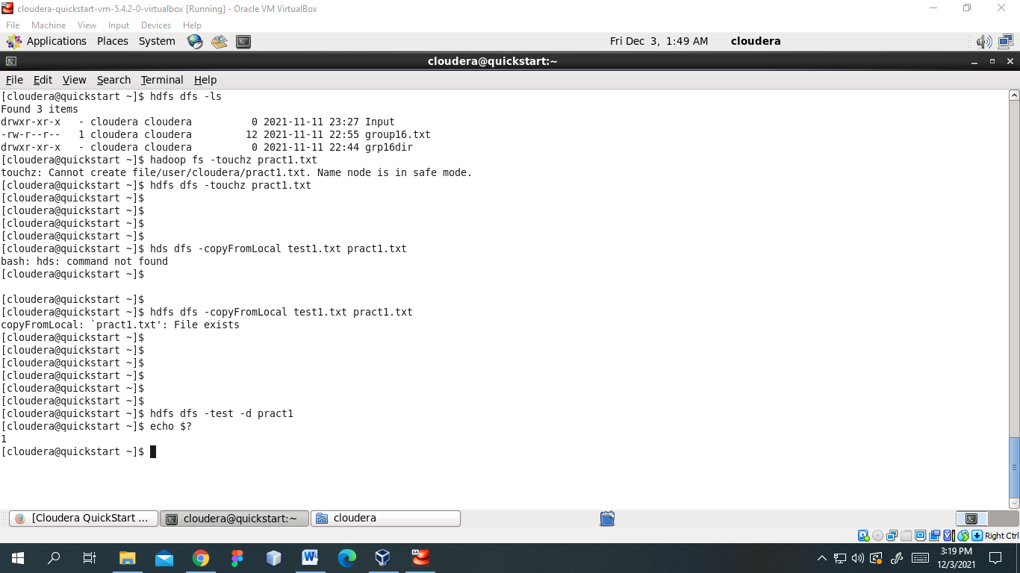

-mkdir

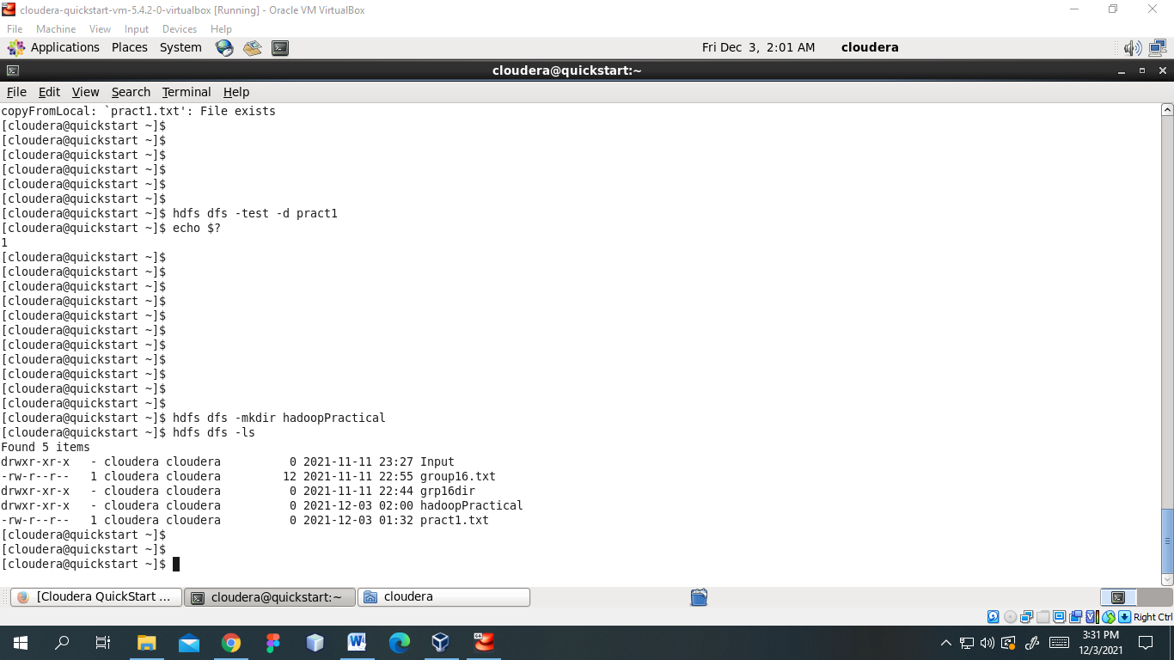

-appendToFile

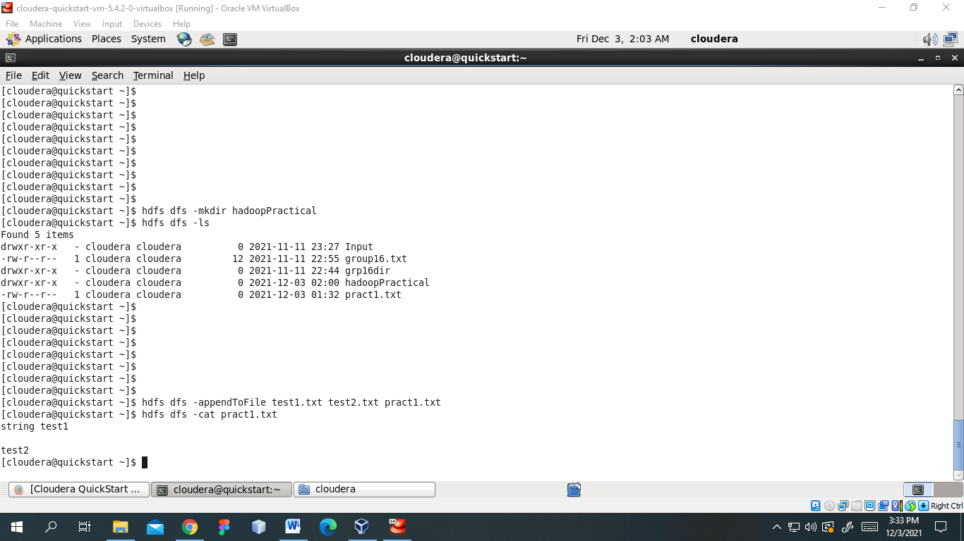

Test1.txt

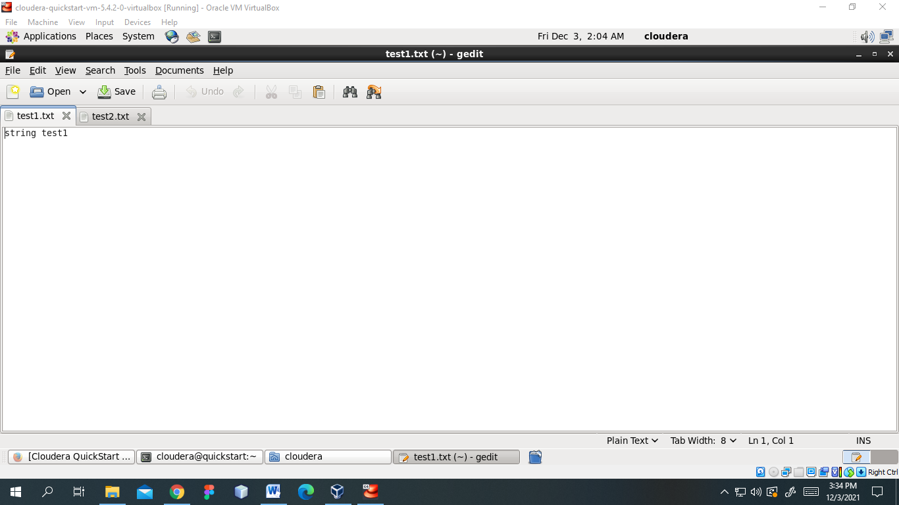

Test2.txt

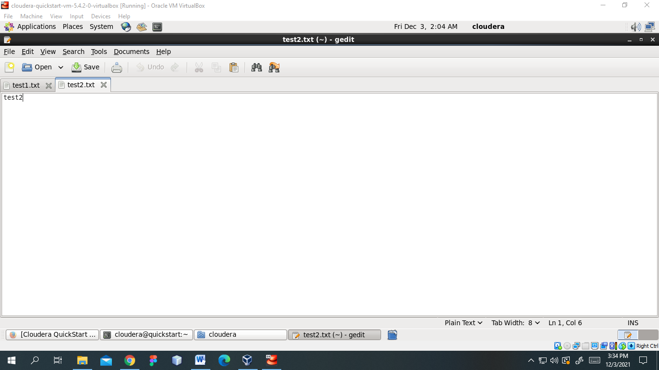

-usage

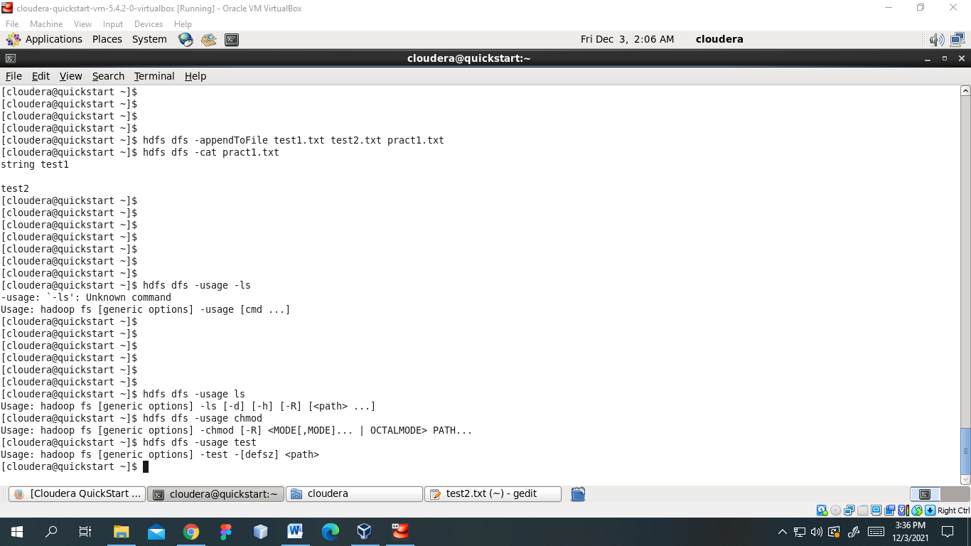

**Practical No. 2**

**Aim: -** Map ReduceWrite a program in Map Reduce for Matrix Multiplication

1. Prerequisites create the input directories to store the input matrices M and N

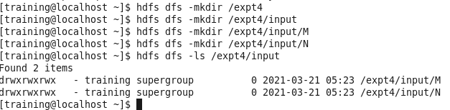

The figure below shows the matrix data used for this implementation:

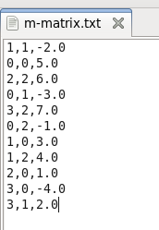 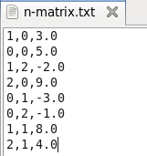

1. Copy the matrix data from the local system to HDFS

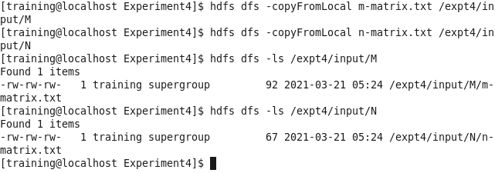

1. Compile the code to create the classes



All the classes created are shown below:

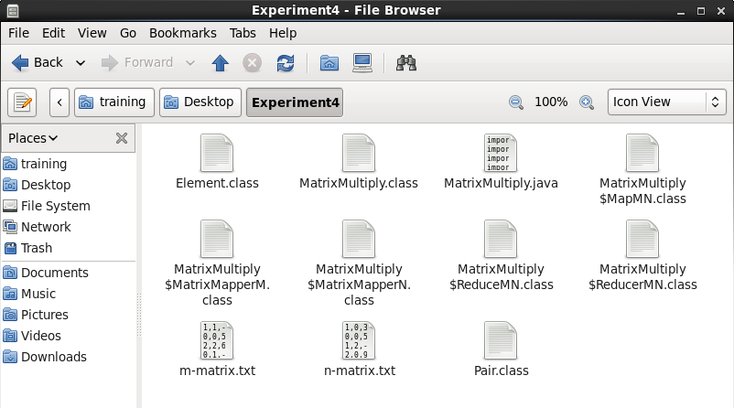

1. To indicate the main class file, create a Manifest file to point out to the main driver class.

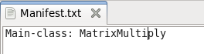

1. Compile and create the Jar file required to run the MapReduce Task



The jar file created is shown below:

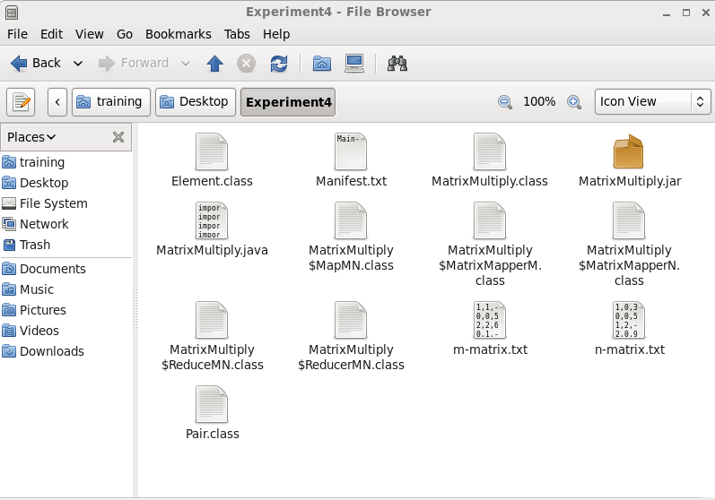

1. Run the jar file on the Hadoop ecosystem to trigger all the MapReduce classes.

The screenshot below shows the completion of Job 1 ie. the first set of MapReduce required to gather and multiply the elements.

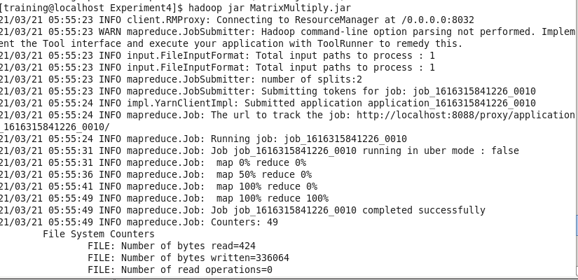

The screenshot below shows the completion of Job 2 ie. the first set of MapReduce required to sum all the calculated product key-value pairs.

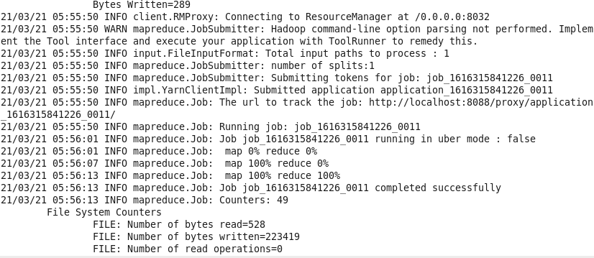

Shows the successful completion of both the MapReduce tasks.

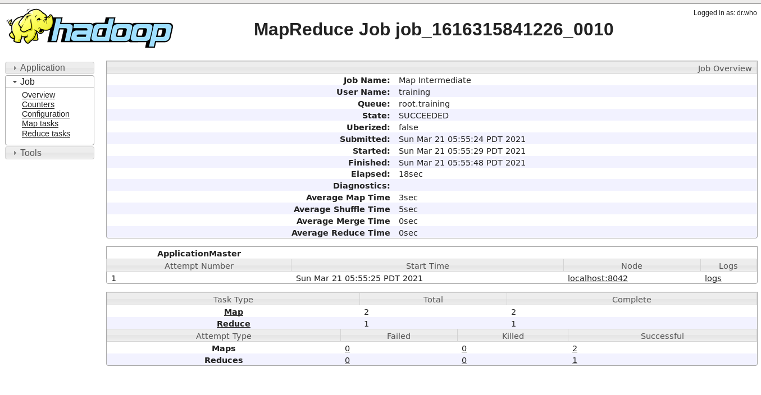

1. Results generated after successful execution of the code.

The output of the first MapReduce task

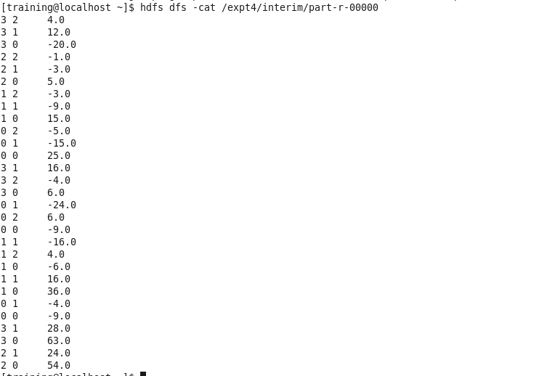

The final multiplication of both the matrices and the output of the second MapReduce Task

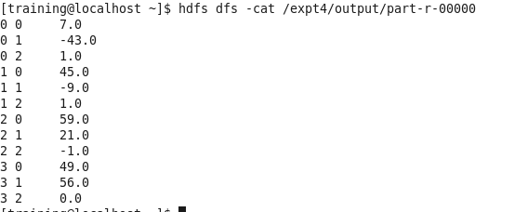

**Conclusion**

Using 2 MR tasks, we were able to read files from two text files and perform matrix multiplication on the stored matrices.

**Practical No. 3**

**Aim:** Installation and Creation of Database and Collection.

**Steps:**

1.Download MongoDB executable .msi file from the site [MongoDB Download Centre](https://www.mongodb.org/downloads). Select the latest version for Windows 10.

2. Then navigate to your downloads folder and double click on the .msi package you just downloaded. This will launch the installation wizard.

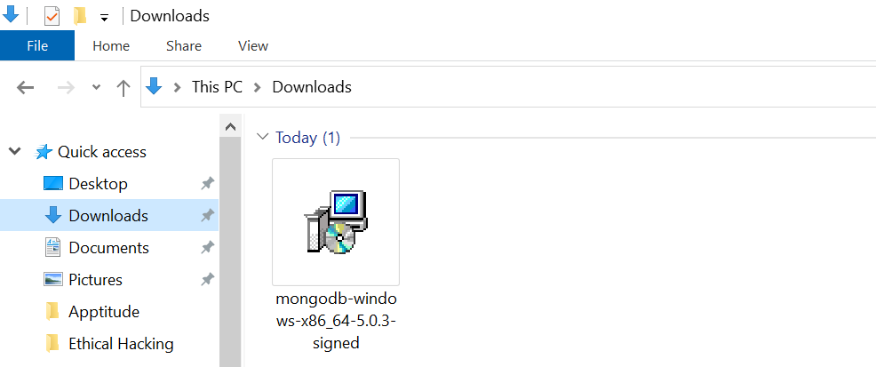

3. Click Next to start installation.

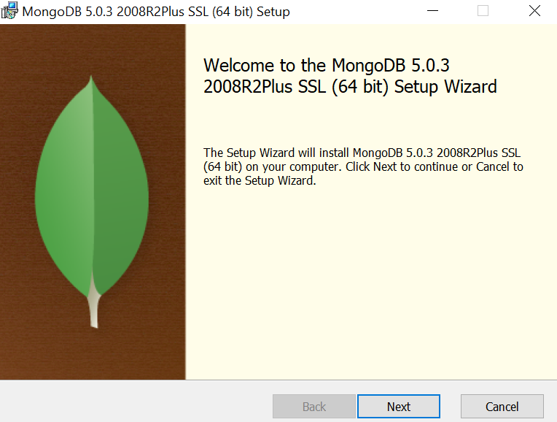

4. Accept the licence agreement then click Next.

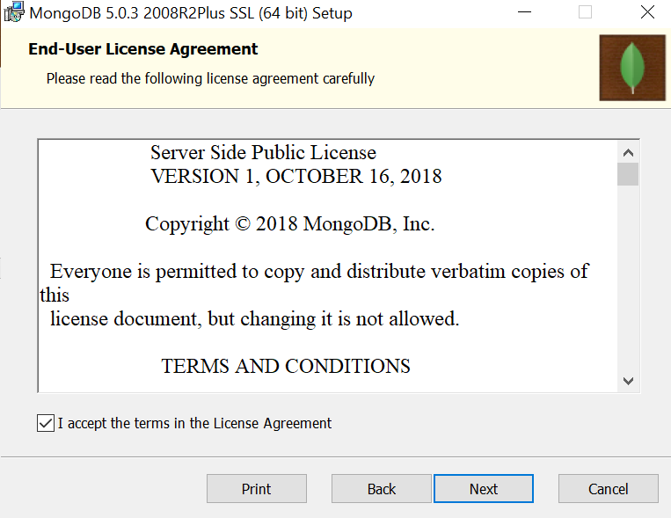

5. Select the Complete setup.

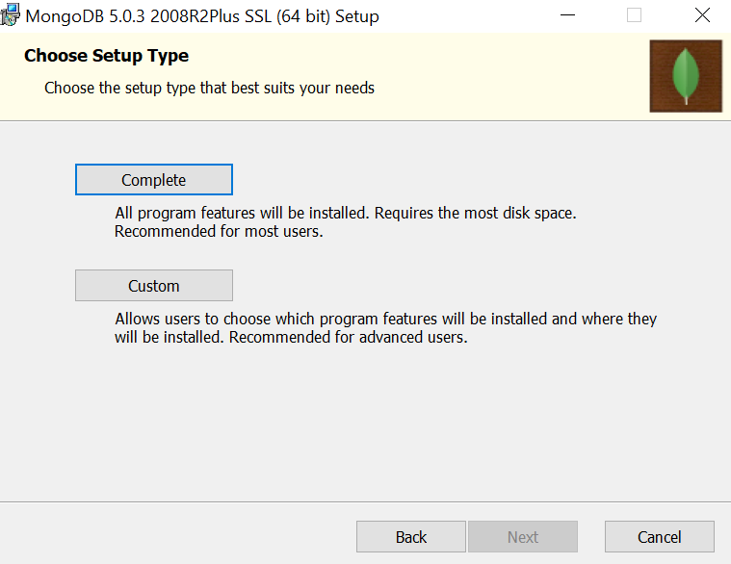

6. Select “Run service as Network Service user” and make a note of the data directory, we’ll need this later.

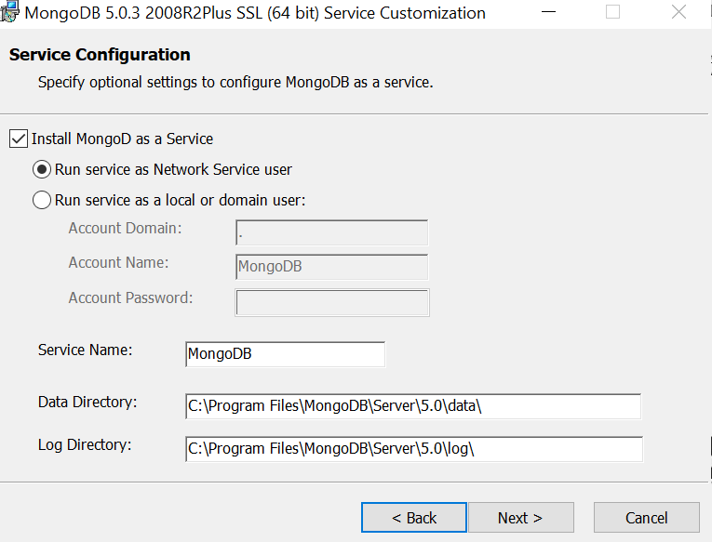

7. We won’t need Mongo Compass, so deselect it and click Next.

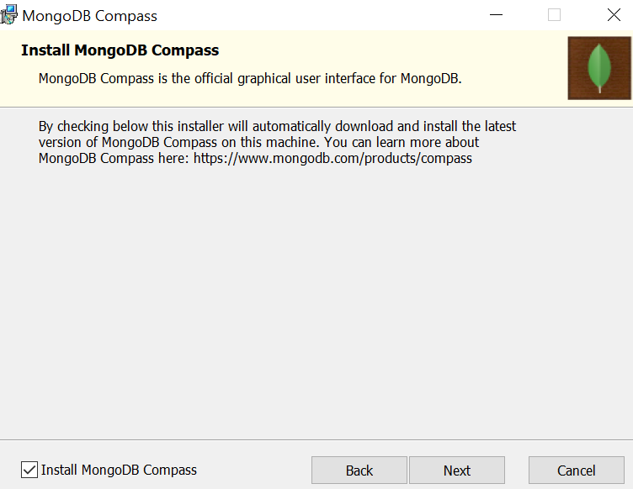

8. Click Install to begin installation.

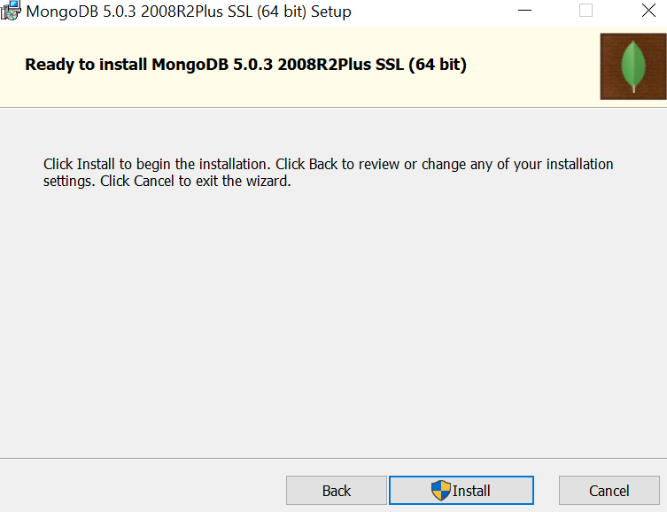

9. Hit Finish to complete installation.

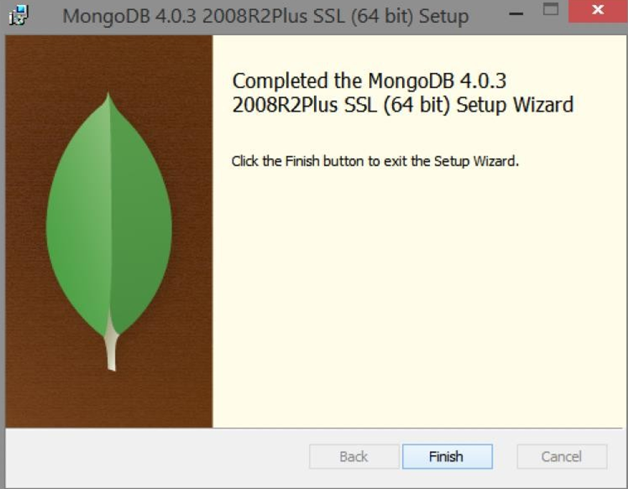

10. It is required to set up the MongoDB environment. MongoDB stores all its data under the folder data\db. It is best practice to create this directory under the folder where the MongoDB is installed. So let's create a folder named data.

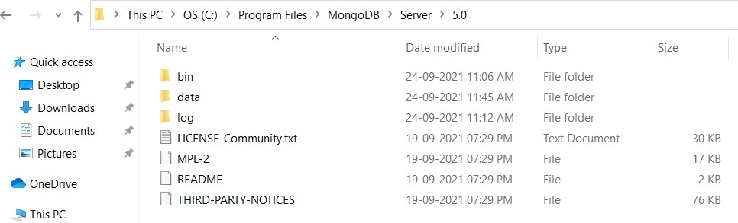

11. Create an environment variable for the executable file so that you don’t have to change the directory structure every time you want to execute the file.

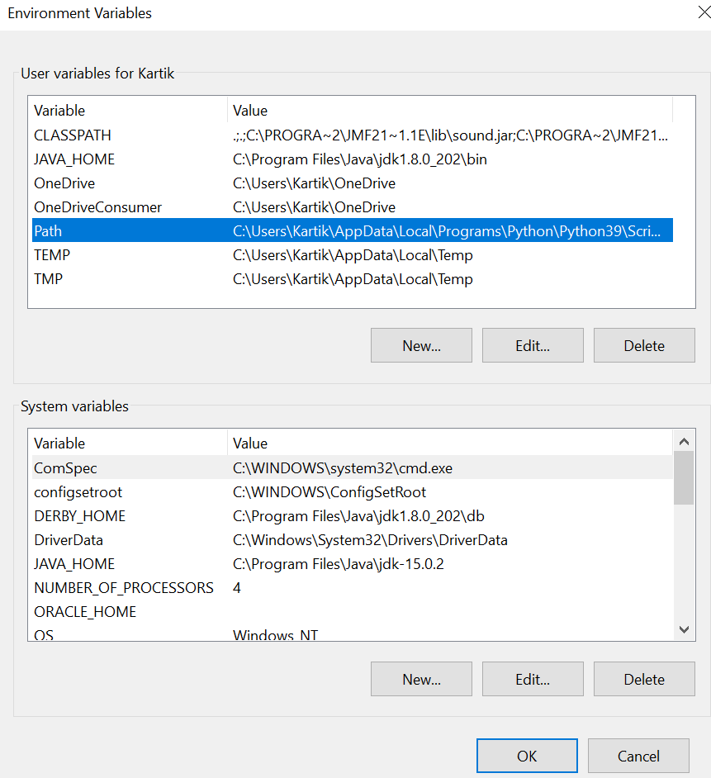

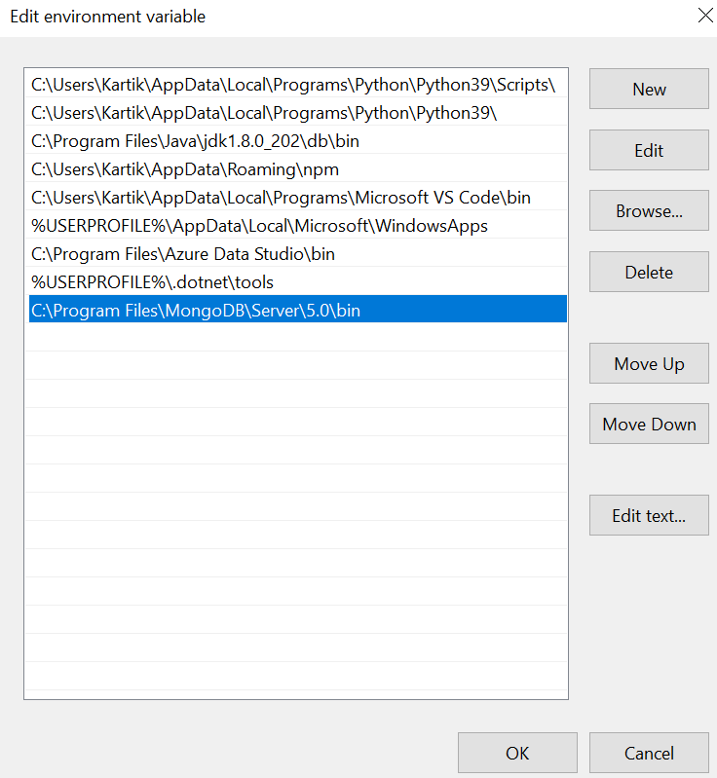

12. After creating an environment path, you can open the command prompt and just type in mongo and press enter.

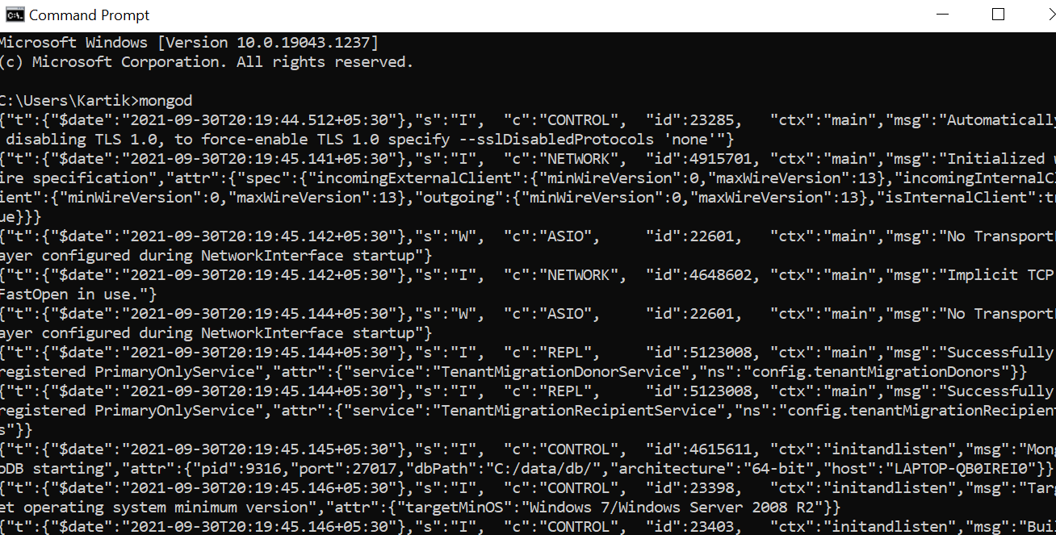

13. The mongo server is then generated and is up and running.

14. To verify if it did the setup correctly, type in the command show DBS.

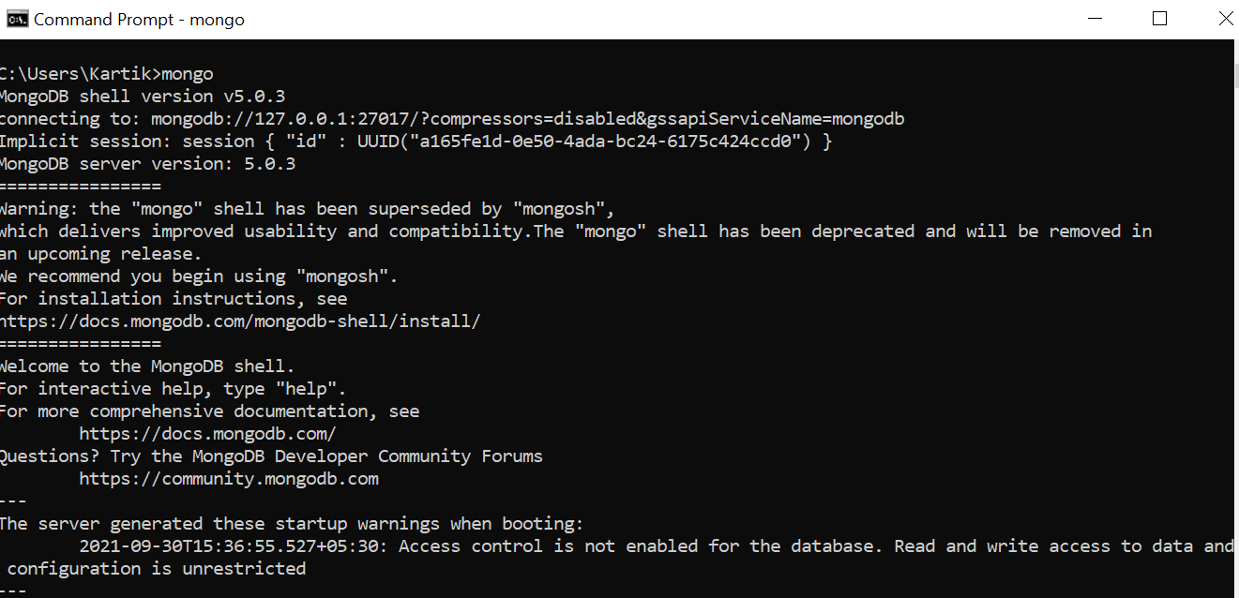

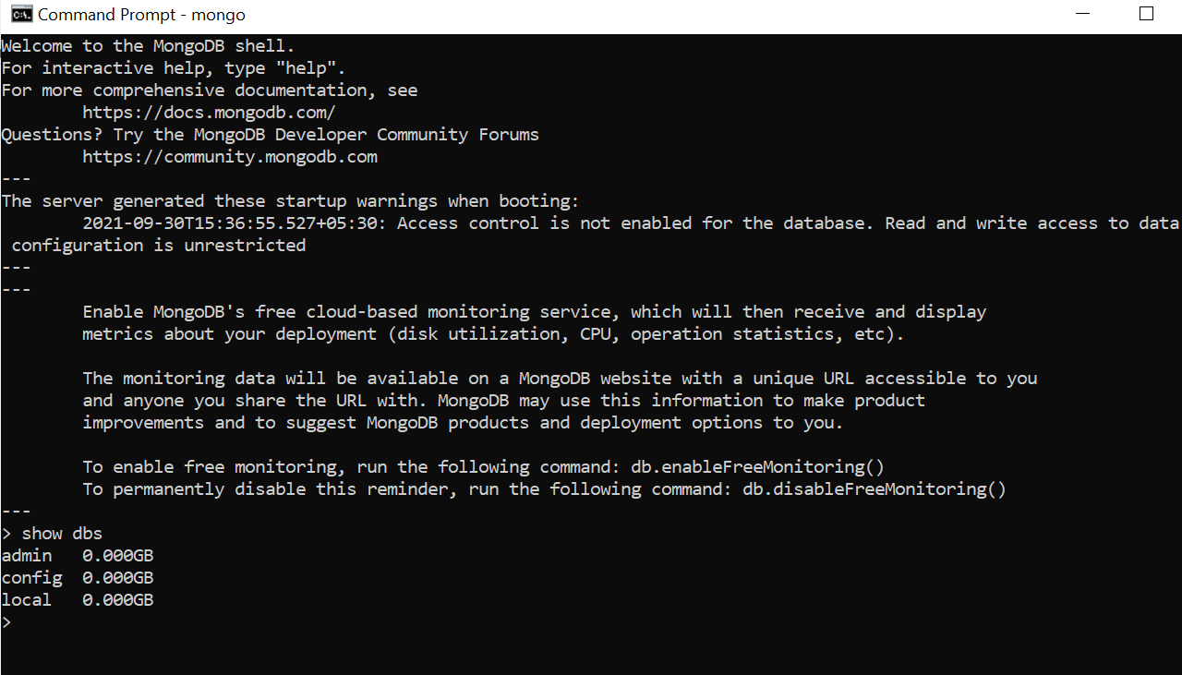

15. With that, you have successfully installed and set up MongoDB on your Windows system.

**Creation of Database and Collection.**

* Create Database

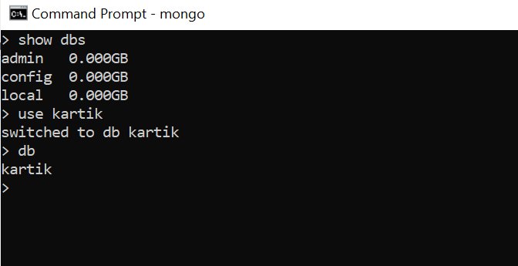

* Create Collection

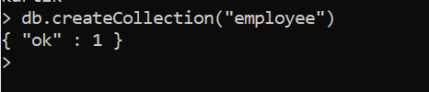

**CRUD Operations: Insert, Query, Update and Delete Operations**

* Insert document

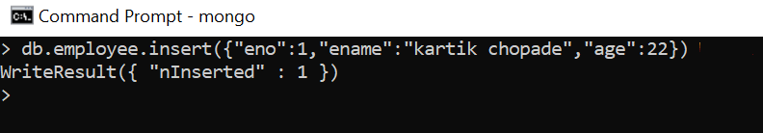

* Query document

1. Find ()

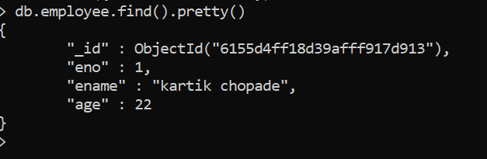

1. Findone ()

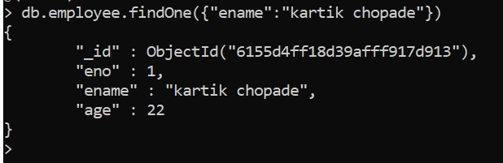

* Update document

1. Update ()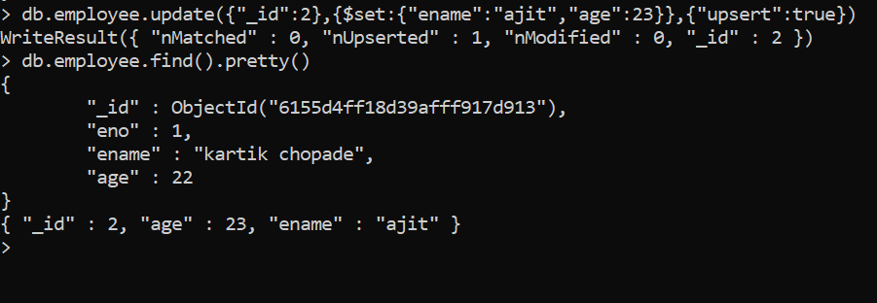
2. UpdateMany ()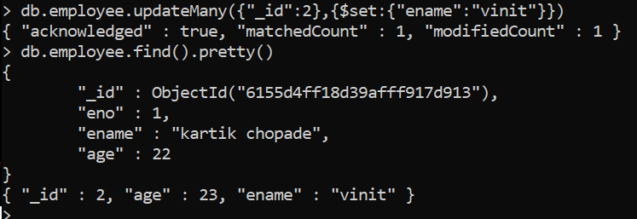

* Delete document

1. Deleteone ()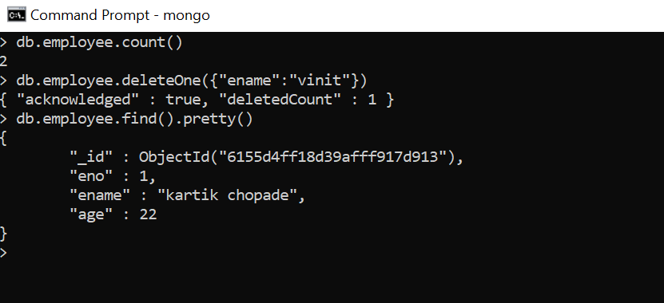
2. Deletemany ()

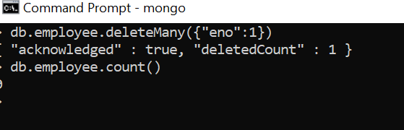

**Practical No. 4**

**Aim: -** HiveList of Commands

Create table

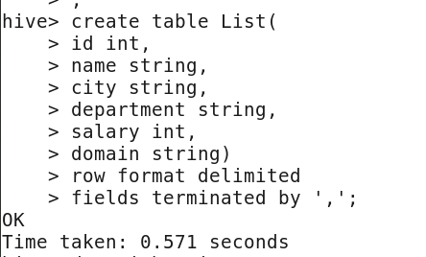

Describe table

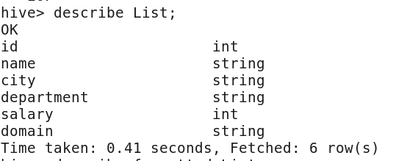

Describe formatted table

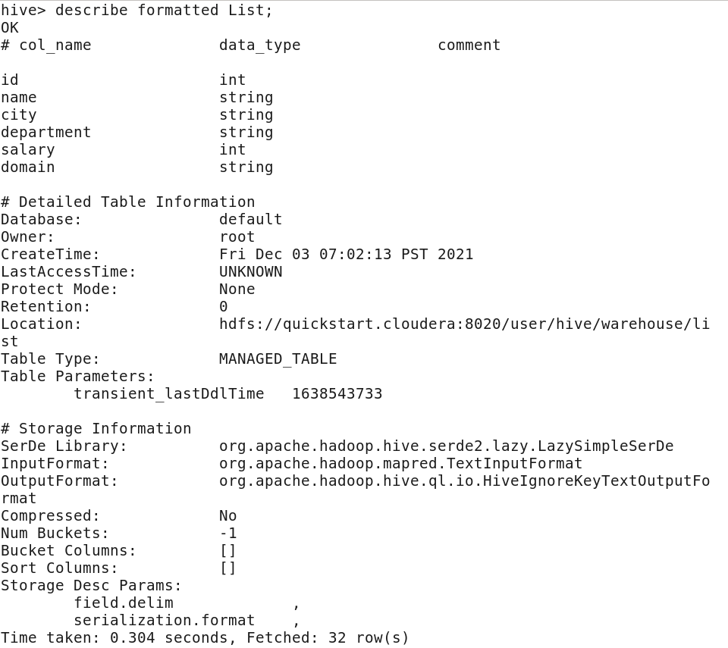

Select * from table

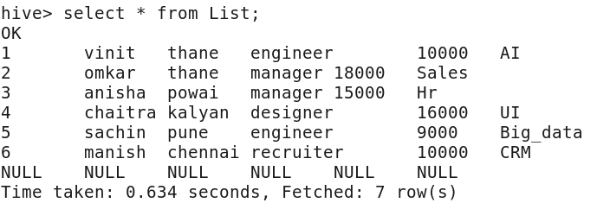

Select from table with limit

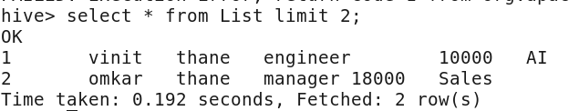

Alter table name

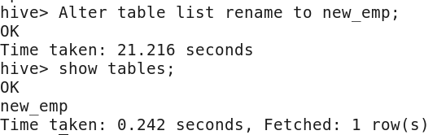

**Practical No. 5**

**Aim: -** Pig:List of Commands

Indata.txt

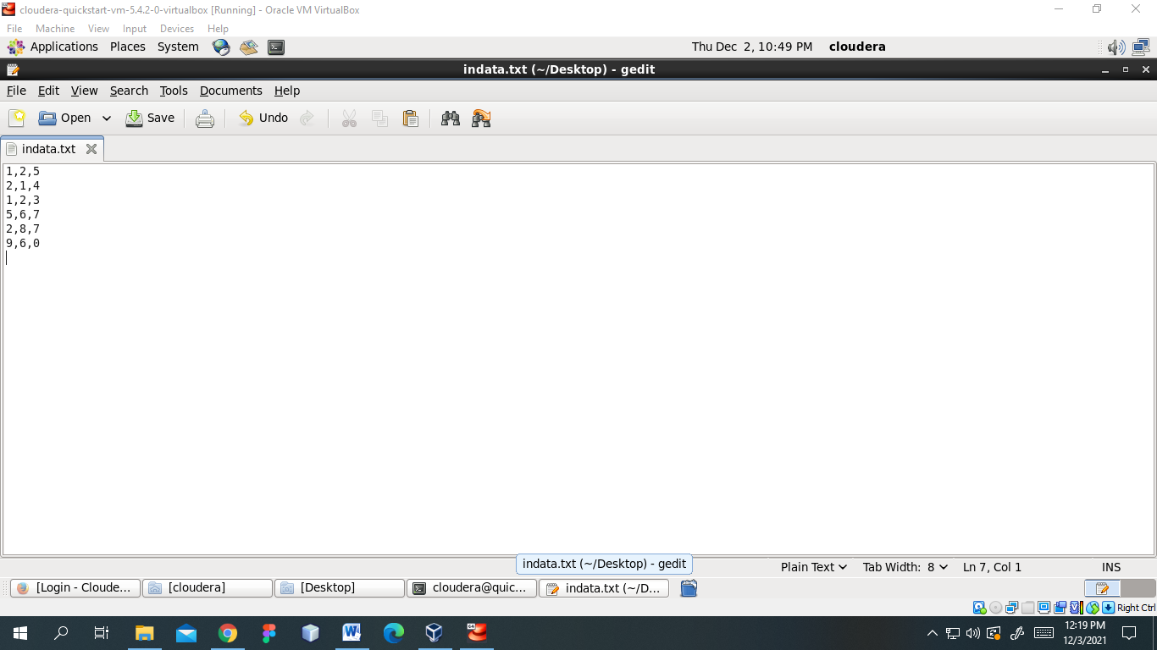

Pig -x local

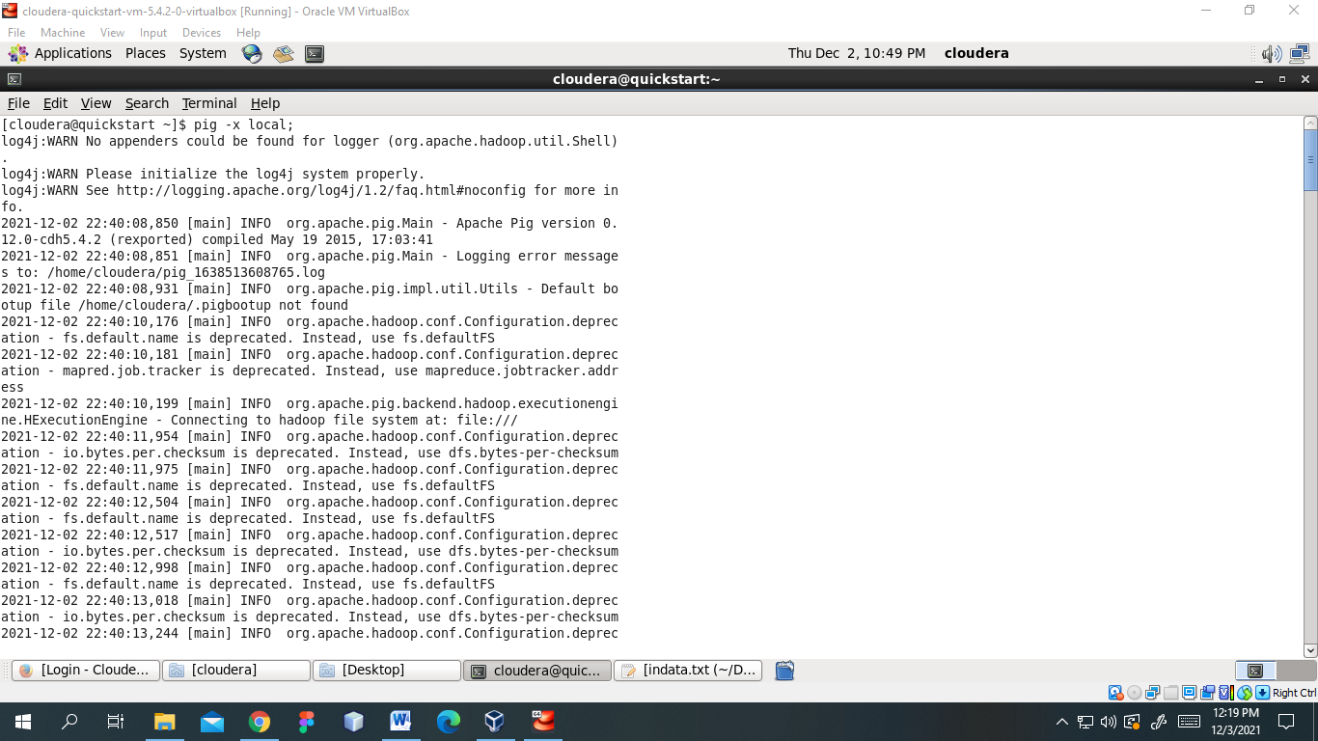

Load data & dump data

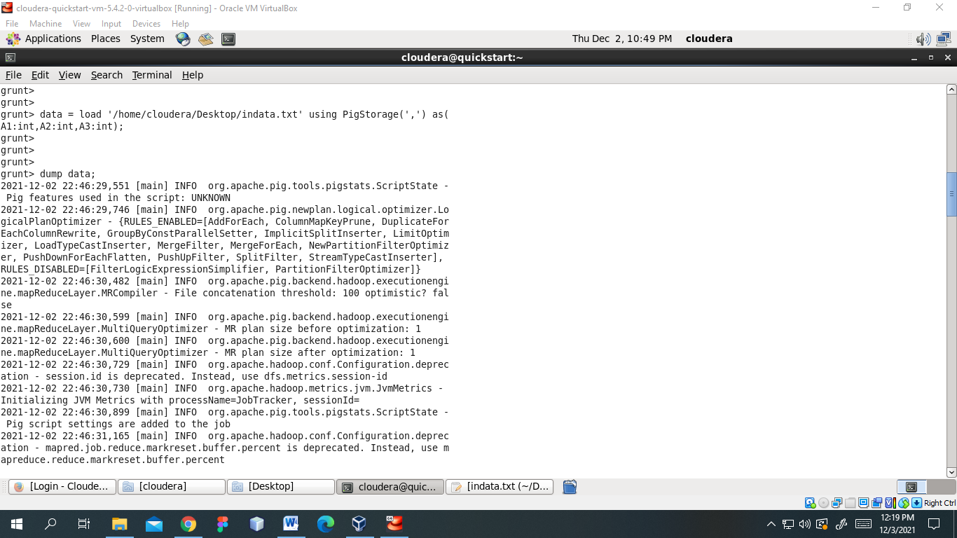

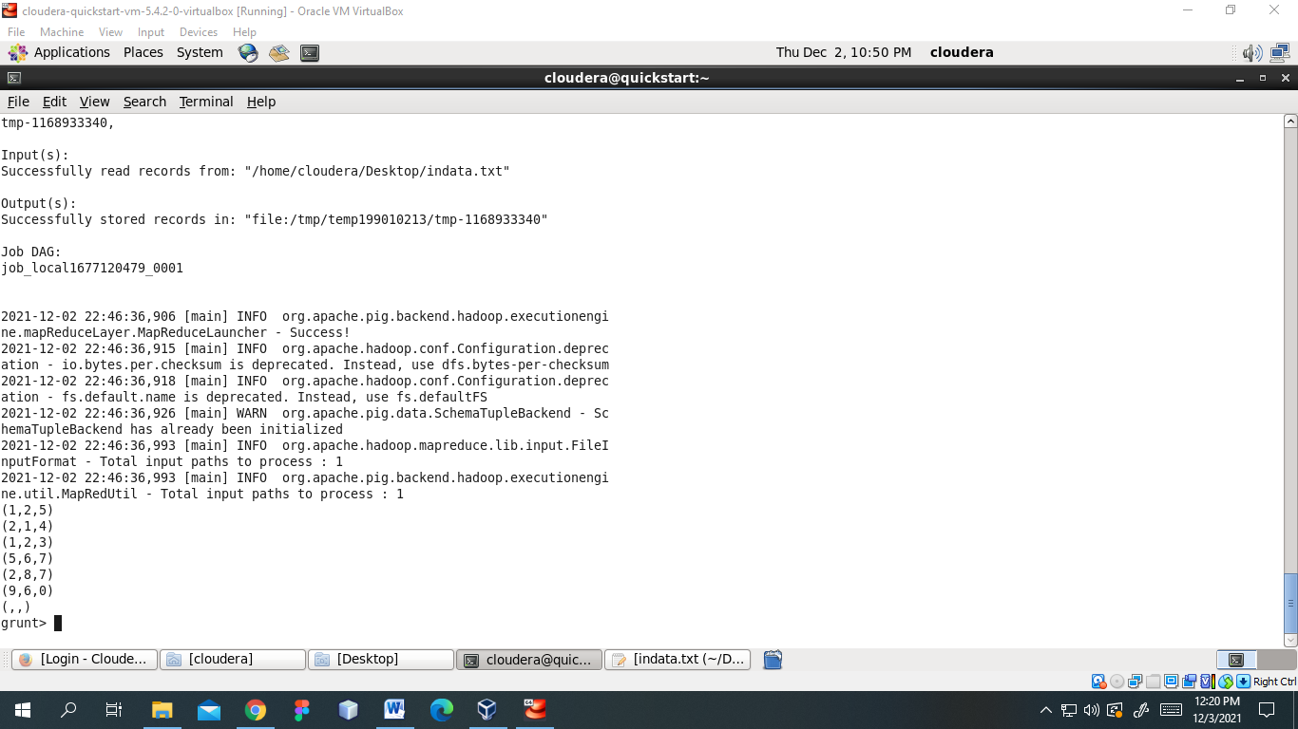

Filter

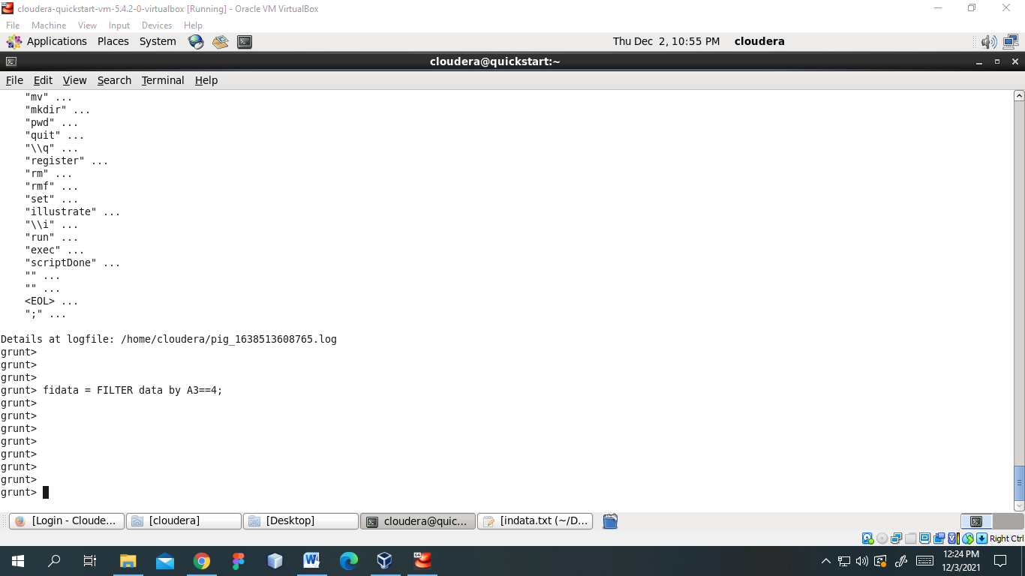

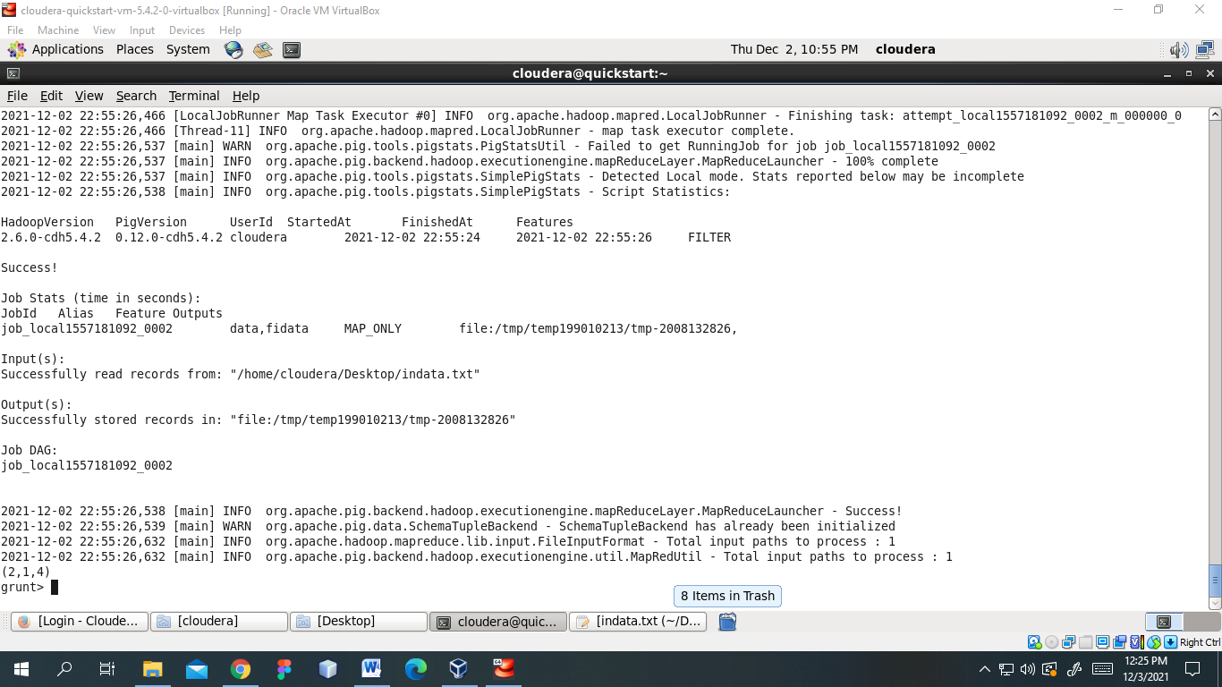

Distinct :

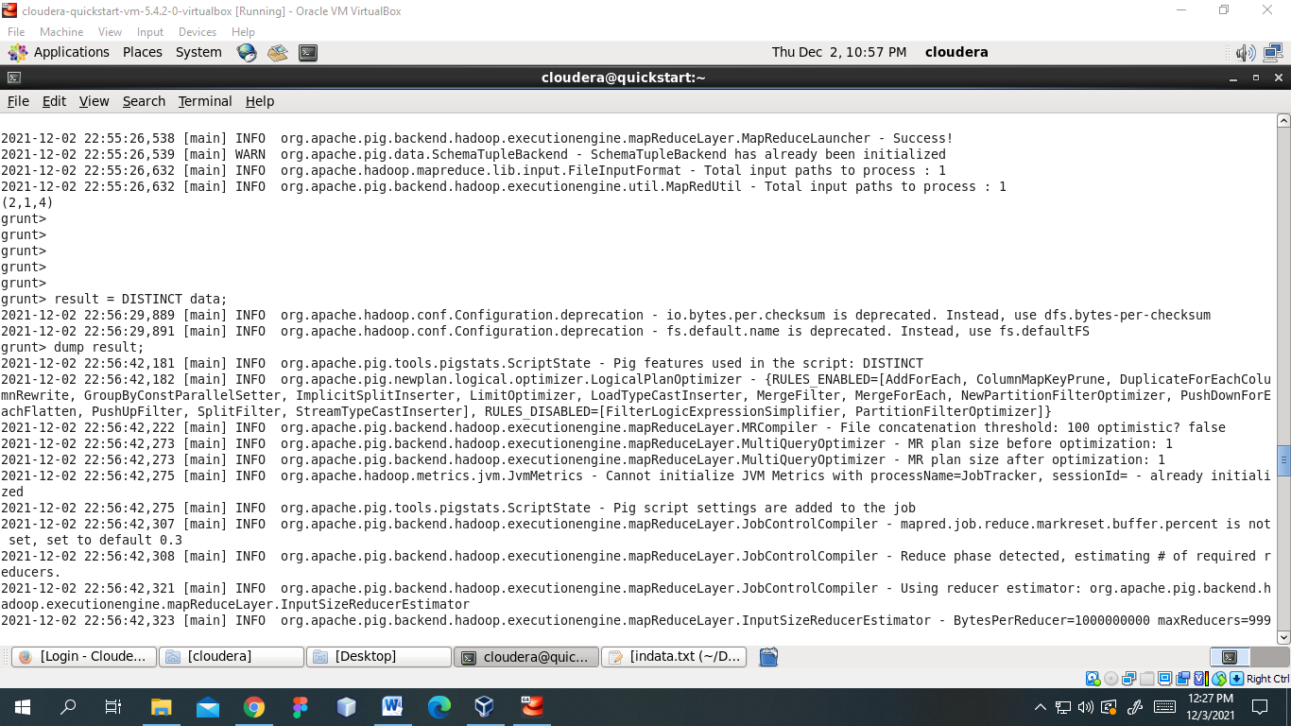

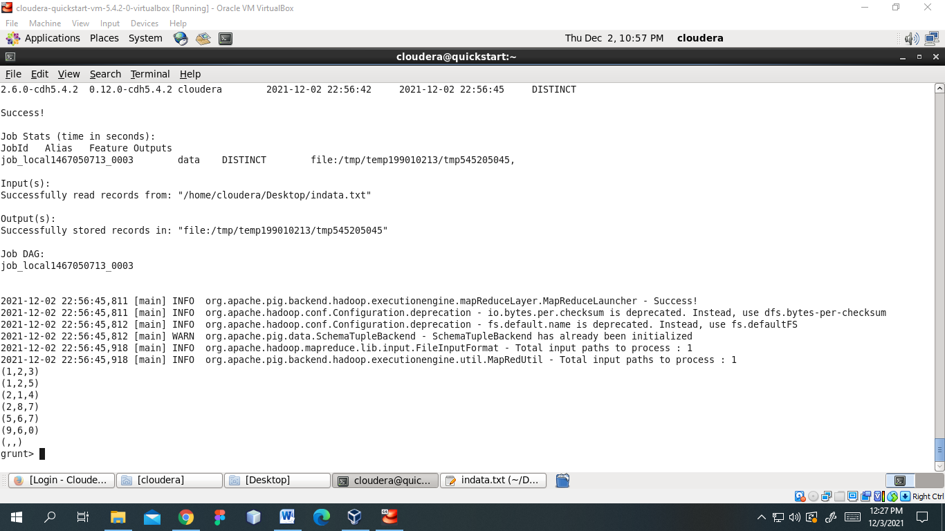

Foreach:

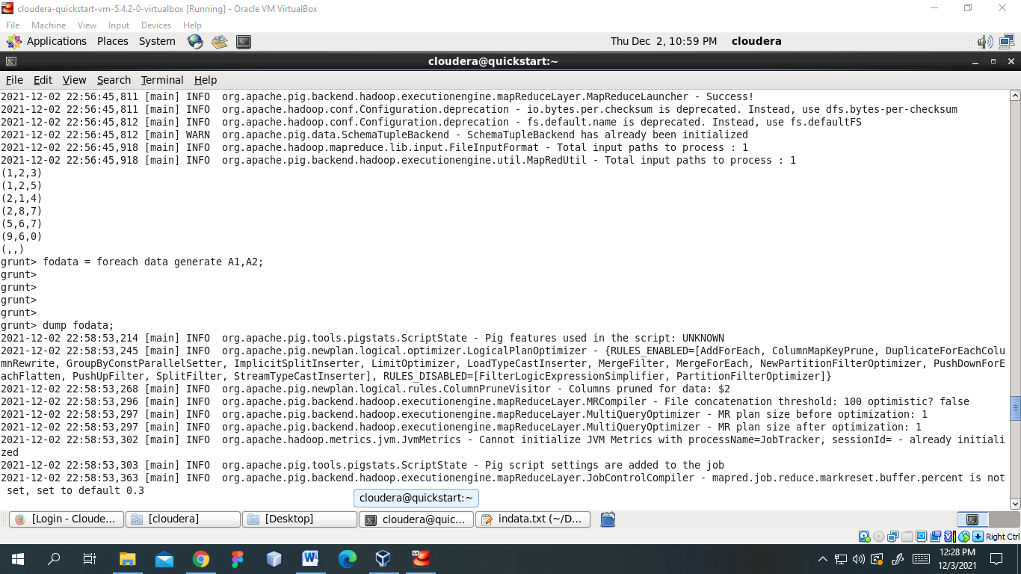

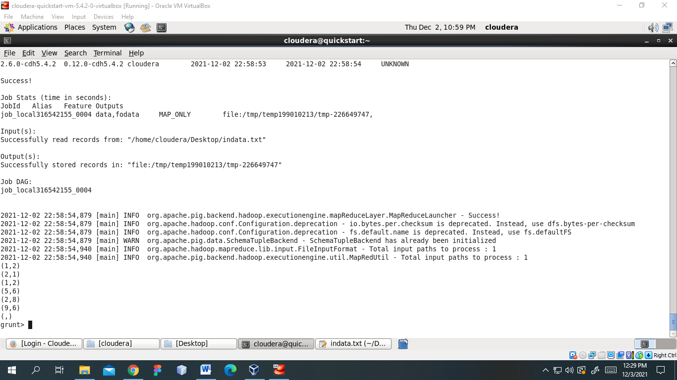

Student.txt

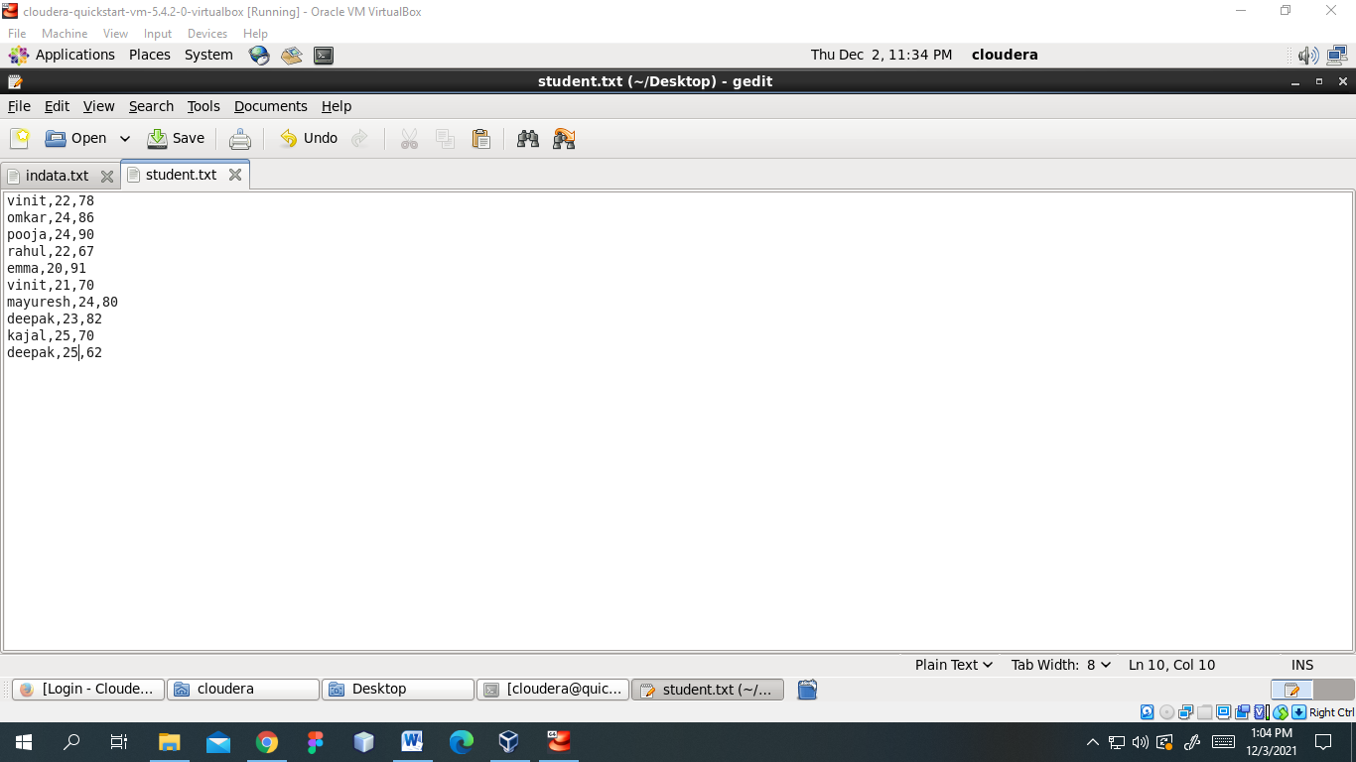

Load

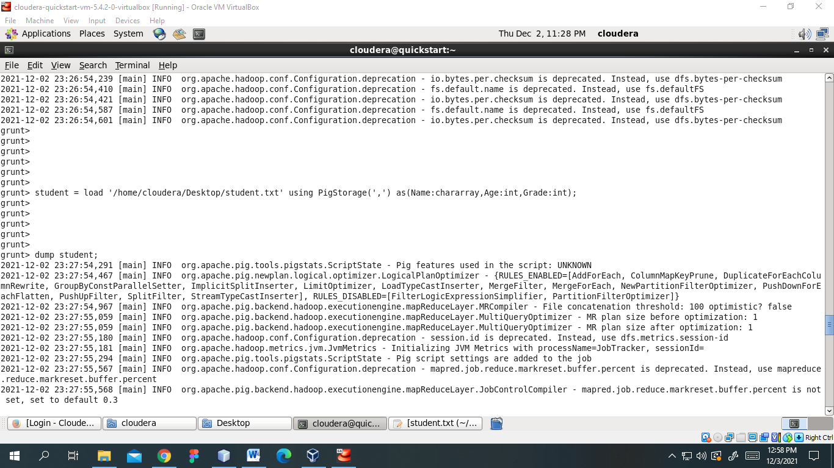

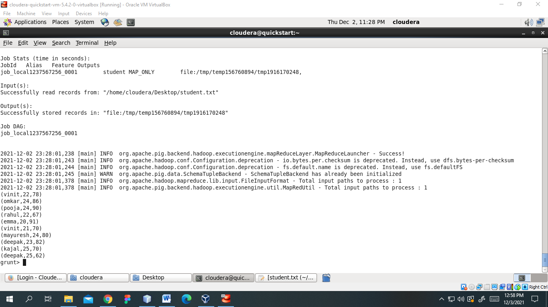

Group-by

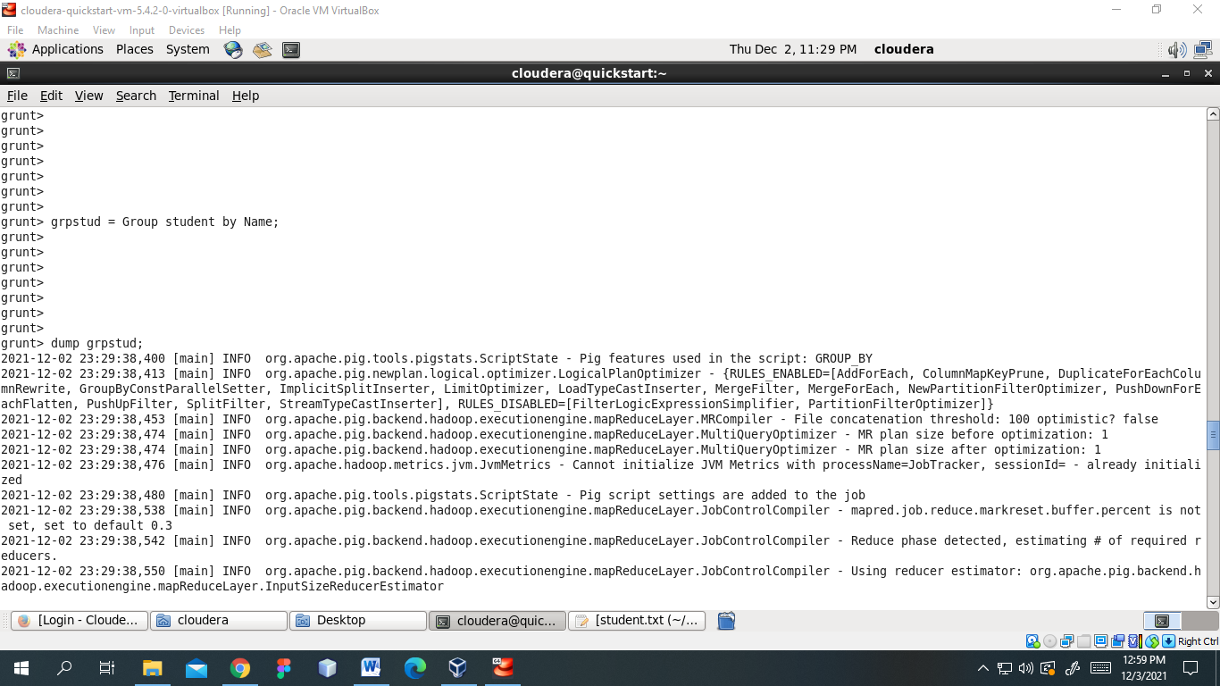

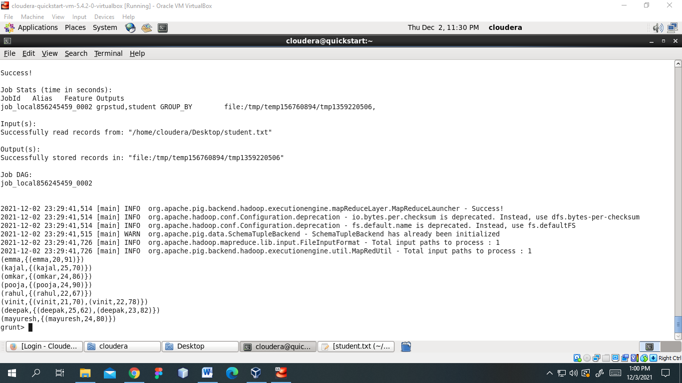

Limit

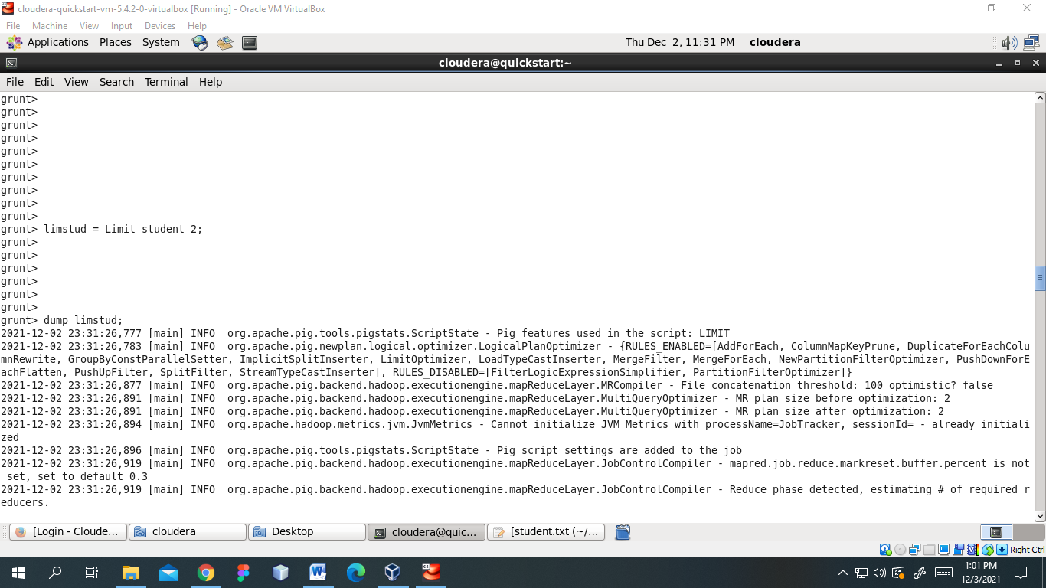

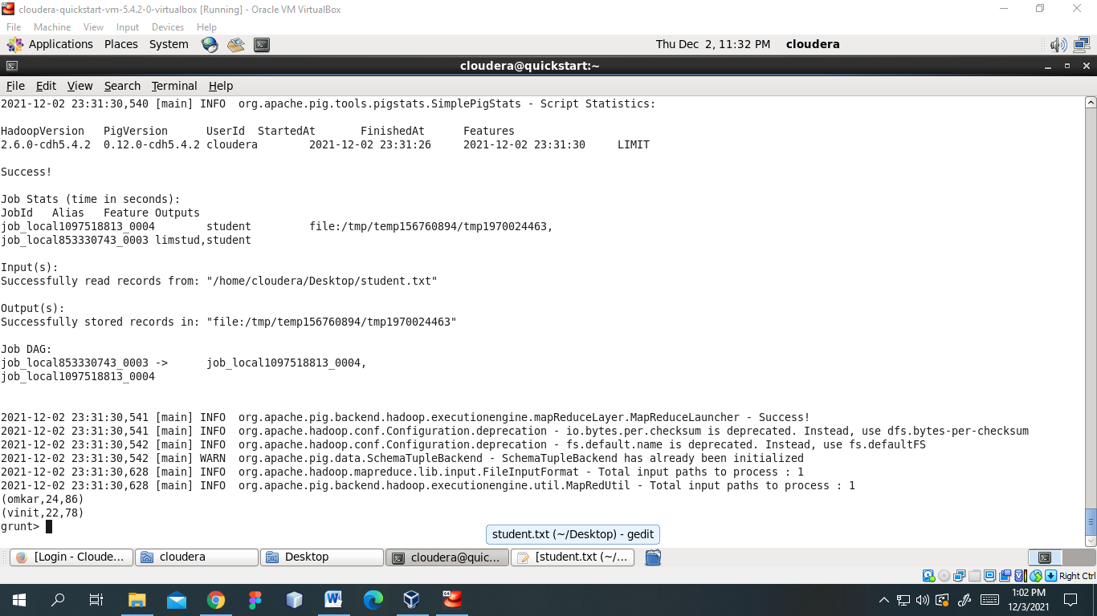

Order ASC & DEC

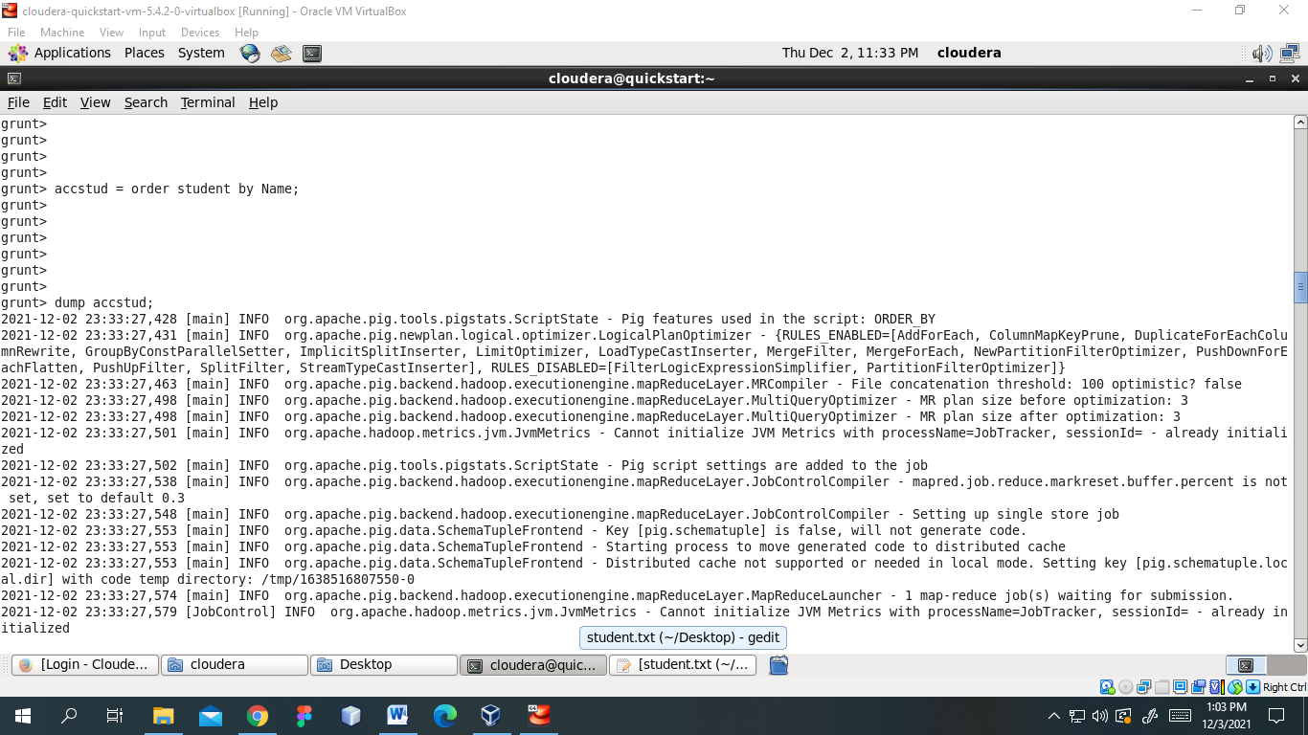

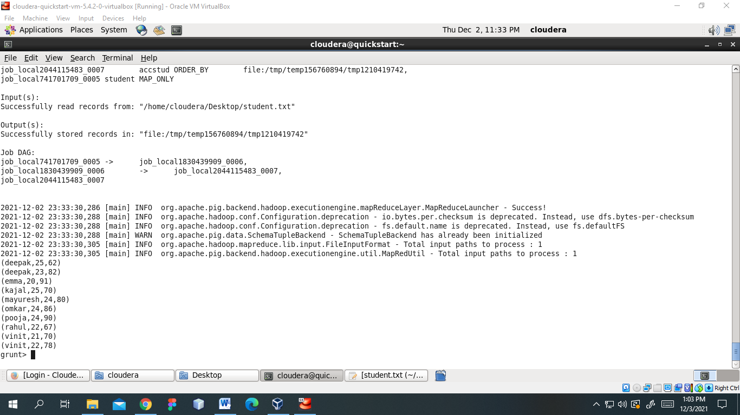 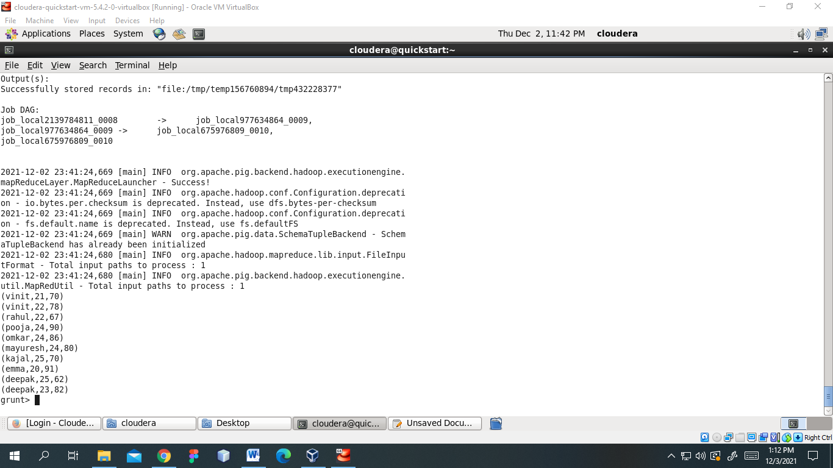

**Practical No. 6**

**Aim: -** SparkList of Commands

Spark-shell

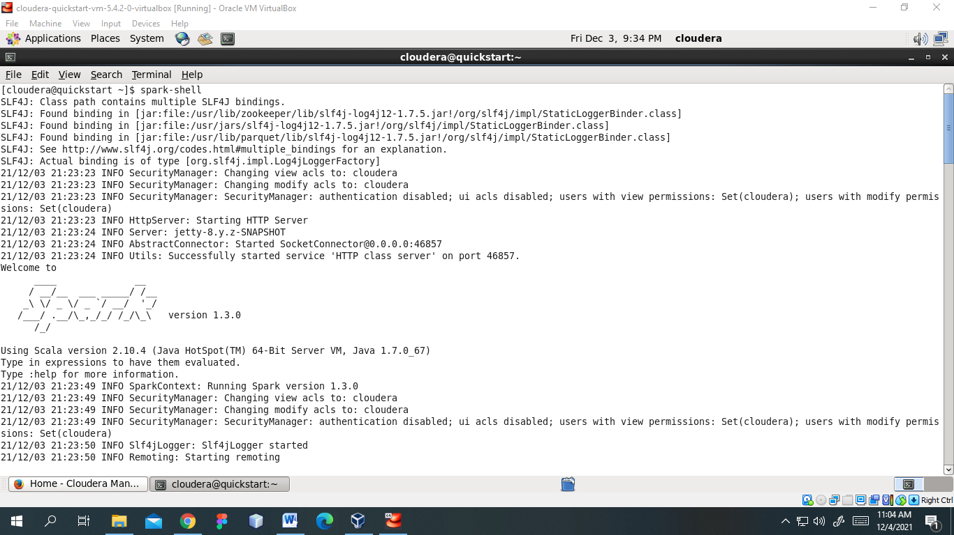

sc.textFile()

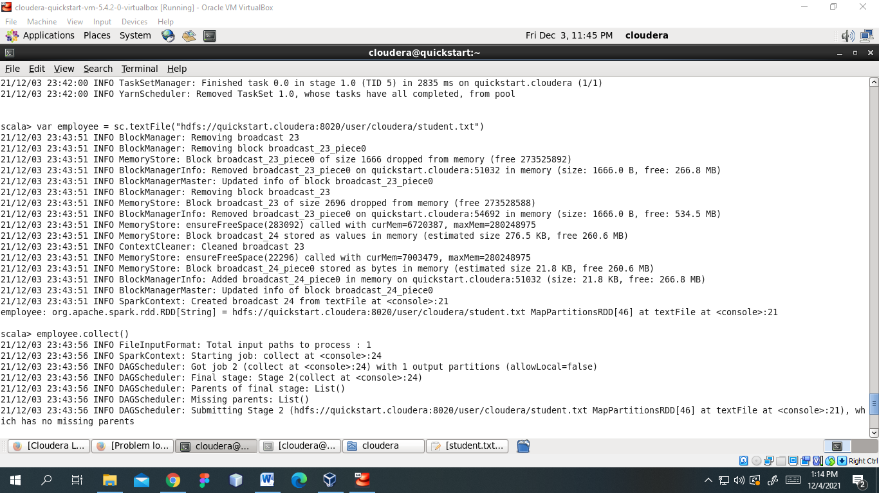

dataset.collect()

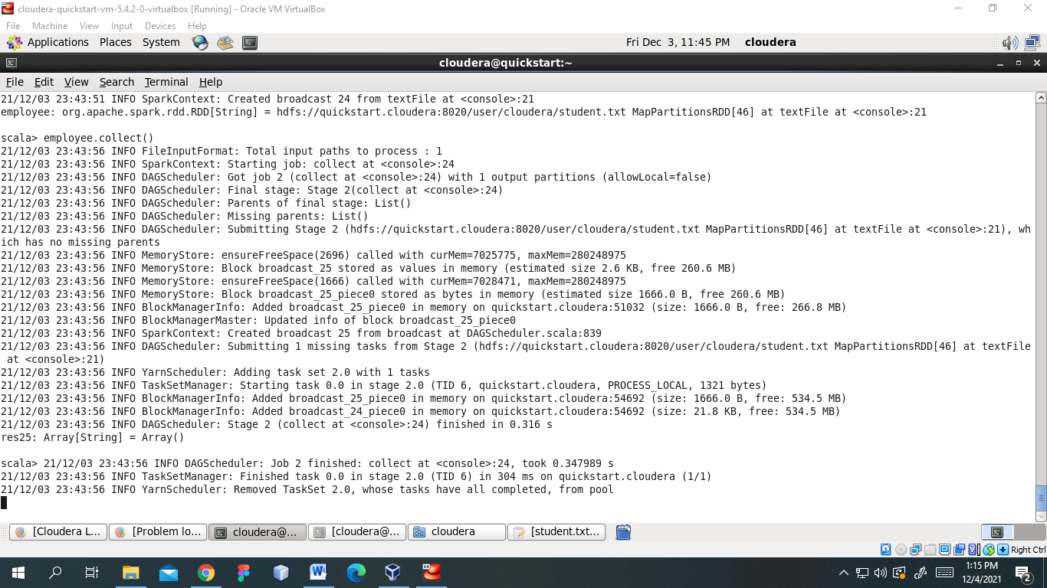

sc.parallelize().collect()s

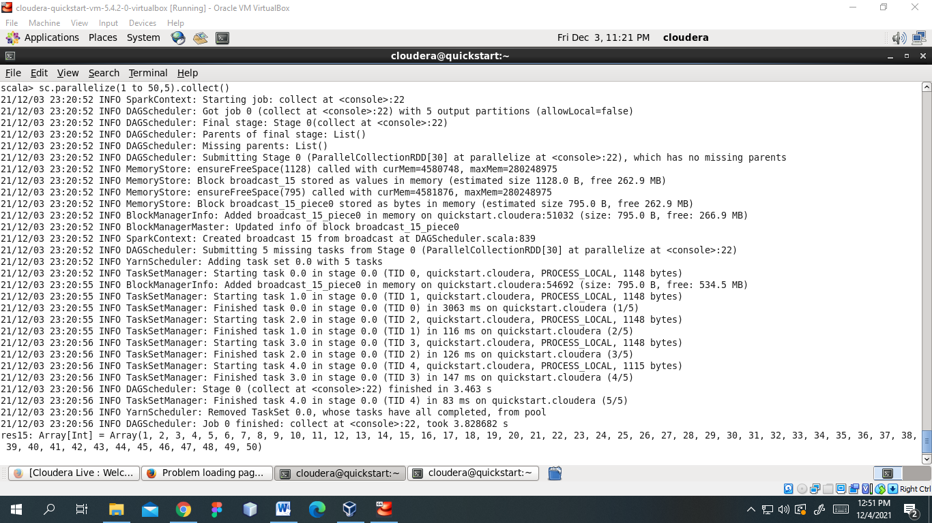



**Practical No. 7**

**Aim: -** Visualization using Tableau

**Adding dataset in worksheet**

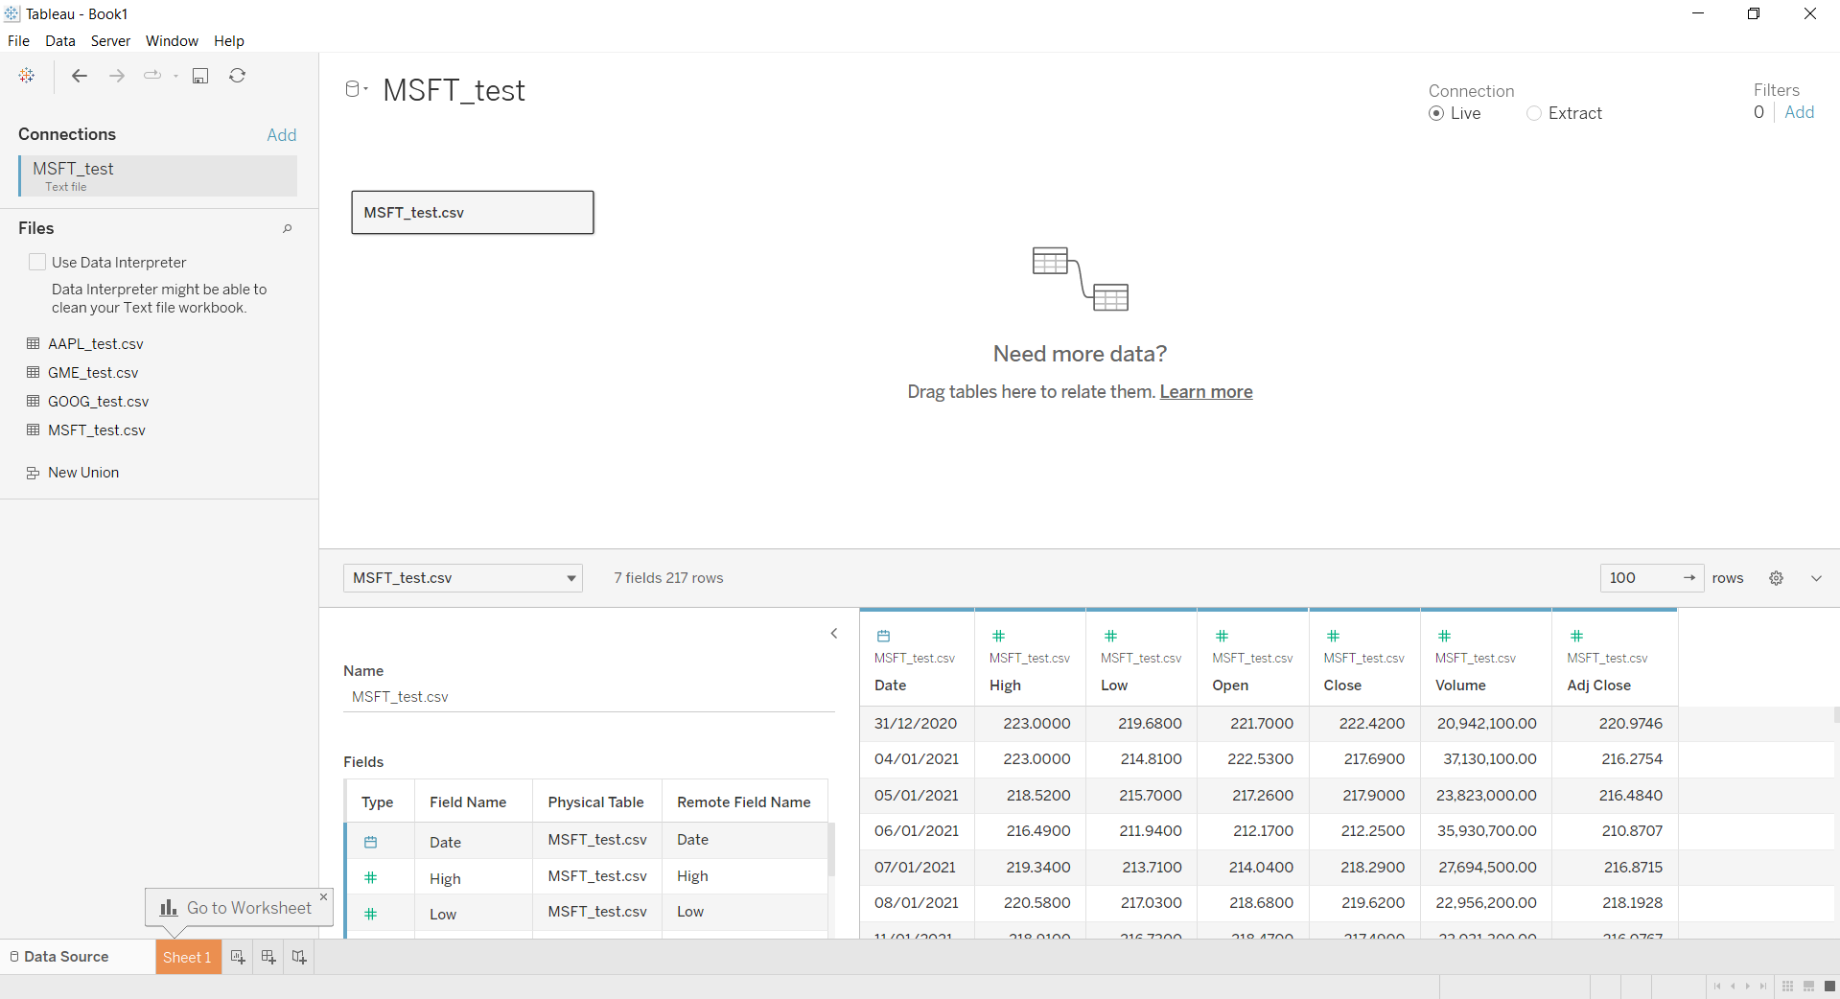

**Adding rows & column in worksheet**

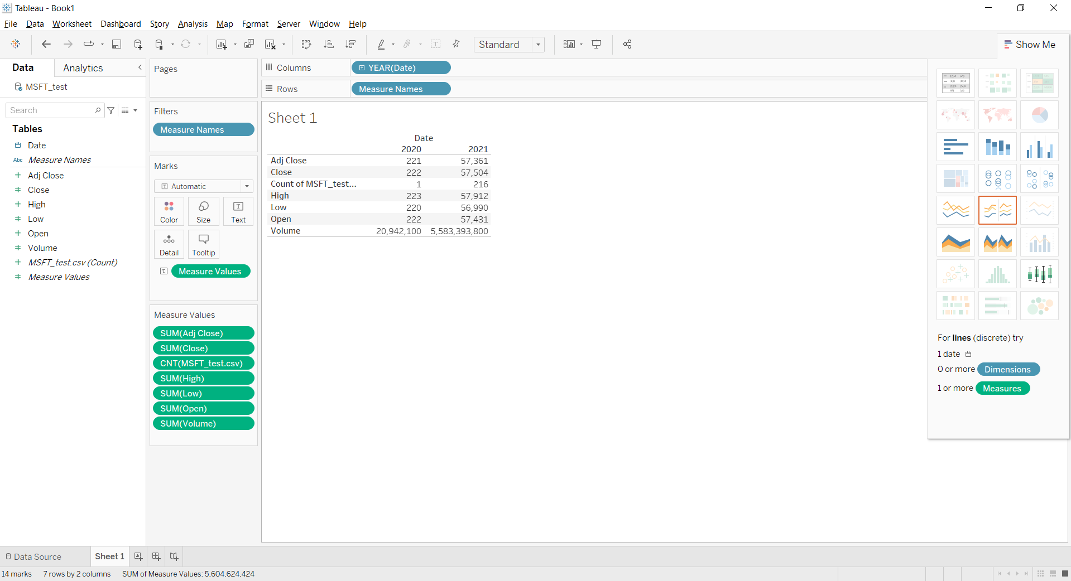

**Viewing graphs**

Volume of data

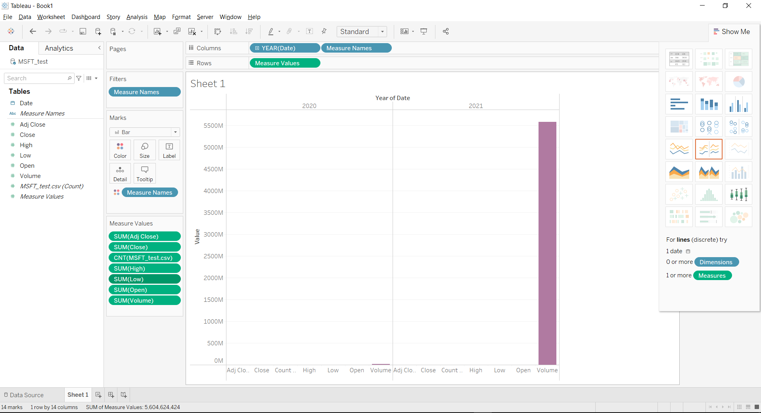

Side bar chart

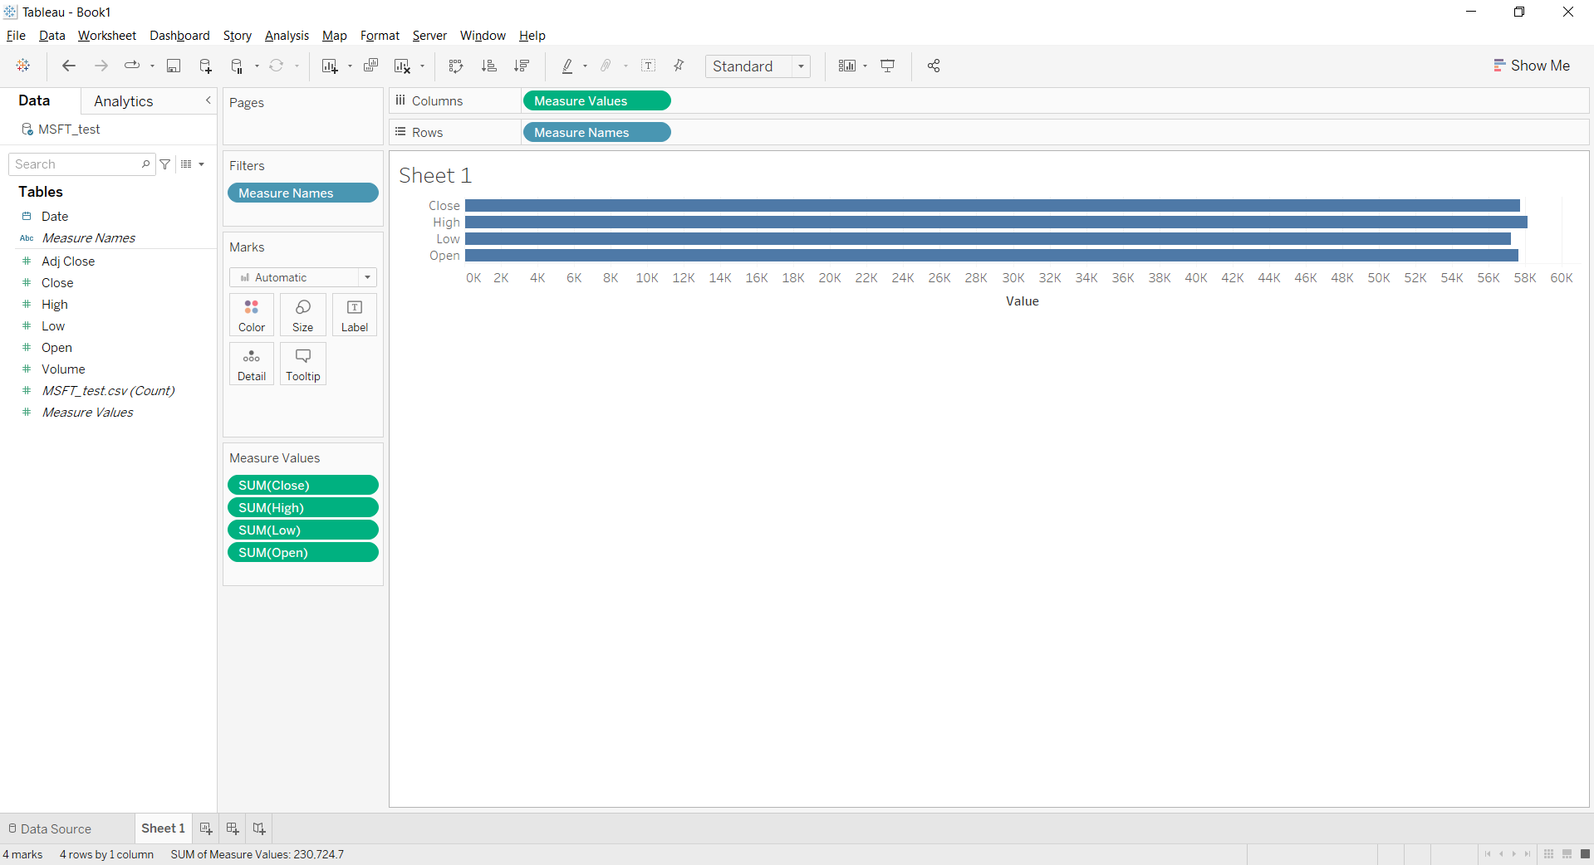

Line graph for multiple rows

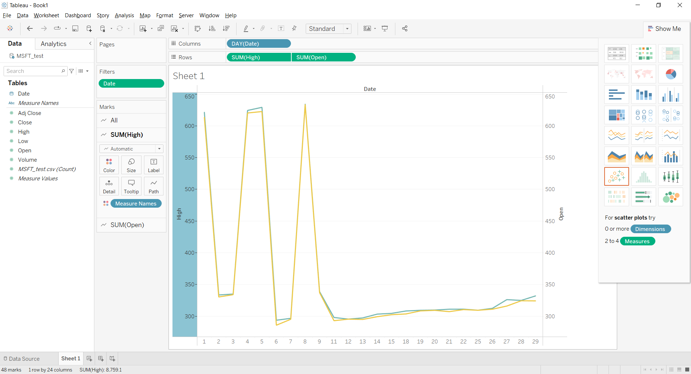

Bar graph for data set

